**Postman Screenshots- Validation on reviews to prevent invalid filmID being entered**

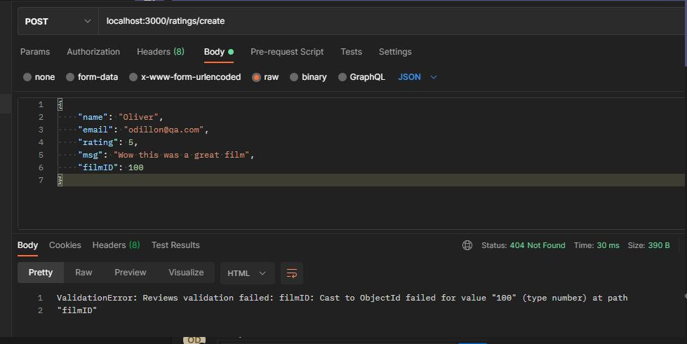

**Postman Screenshots- Valid Review being created**

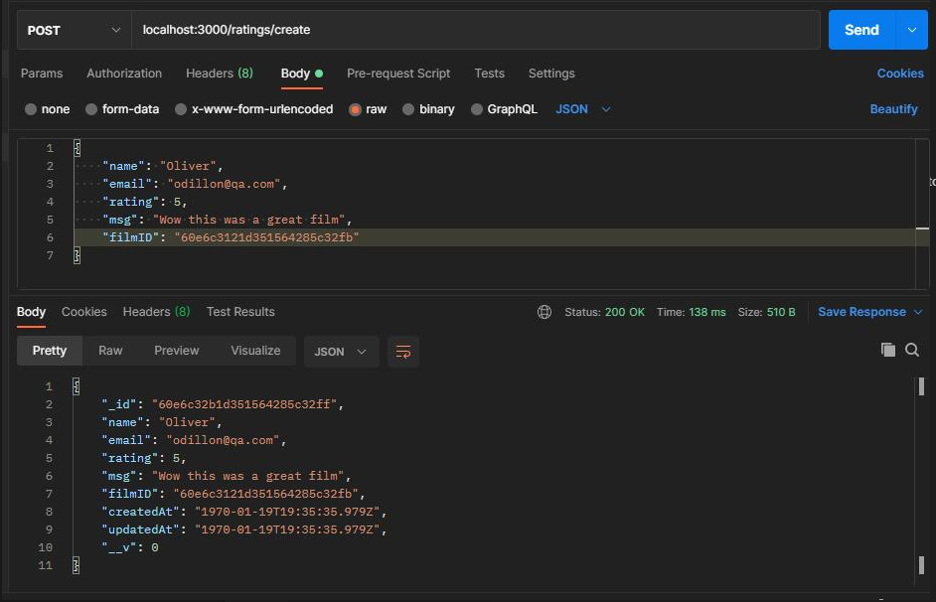

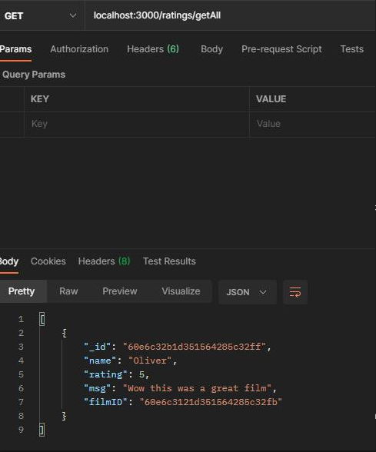**Postman Screenshots- Reviews being returned without sensitive information**